## Artificial Intelligence and Machine

## Learning

Project Report

Semester-IV (Batch-2022)

Emotion Analysis

**Supervised By: Submitted By:**

Dr. Sangeetha Annam Aditya Garg – 2210990064 (G-4)

Akash – 2210990081 (G-4)

Abhinav Rawat – 2210990038 (G-4)

Aditya Mittal – 2210990069 (G-4)

**Department of Computer Science and Engineering**

## Chitkara University Institute of Engineering & Technology,

## Chitkara University, Punjab

**Table Of Contents**

|  |  |  |
| --- | --- | --- |
| Sr.no | Section | Page No |
| 1. | Introduction | 3-7 |
| 2. | Problem Definition and Requirements | 8 |
| 3. | Proposed Design/Methodology | 8-10 |
| 4. | Result | 11 |
| 5. | References | 12 |

1. **Introduction**
   1. **Background**

Emotion analysis based on text messages using machine learning is a field within natural language processing (NLP) that focuses on understanding and categorizing emotions expressed in text data. This technology has applications in sentiment analysis, customer feedback analysis, mental health monitoring, and social media monitoring. The process involves text preprocessing, feature extraction, emotion labeling, and machine learning models like Naive Bayes. Emotion analysis models are trained on labeled datasets and evaluated using metrics like accuracy, precision, recall, F1-score, and confusion matrices.

**1.2 Objectives**

1. Emotion Recognition: Develop models that accurately recognize and classify emotions expressed in text messages.
2. Fine-Grained Emotion Analysis: Aim to go beyond basic sentiment analysis and capture a broader spectrum of emotions. Instead of just labeling text as positive, negative, or neutral, strive to recognize more nuanced emotions such as excitement, frustration, contentment, and curiosity.
3. Real-Time Analysis: Develop systems capable of analysing text messages in real-time, allowing for timely responses and interventions in applications such as mental health support, customer service, and social media monitoring.
4. Evaluation and Benchmarking: Establish standard evaluation metrics and benchmark datasets for assessing the performance of emotion analysis models. Continuously evaluate and refine models to improve accuracy, robustness, and generalization capabilities.
   1. **Significance**
5. Enhanced Understanding of Human Behavior: This understanding can inform decision-making processes in fields such as psychology, sociology, marketing, and human-computer interaction.
6. Improved Mental Health Monitoring: Emotion analysis can be used to monitor individuals' emotional states and identify signs of mental health issues such as depression, anxiety, and stress.
7. Personalized Services and Recommendations: This can enhance user experiences in applications such as content recommendations, e-learning platforms, and health and wellness apps.
8. Effective Customer Feedback Analysis: Businesses can leverage emotion analysis to analyze customer feedback from various sources such as social media, reviews, and surveys.
9. Social Media Monitoring and Public Opinion Analysis: Emotion analysis facilitates the monitoring and analysis of public sentiment on social media platforms. This is valuable for tracking public opinion, detecting emerging trends and issues, and assessing the impact of events and campaigns in real-time.
10. Crisis Detection and Management: Emotion analysis can help identify potential crises or emergencies by detecting emotional distress signals in text data. This is valuable for early intervention and crisis management in situations such as natural disasters, public health emergencies, and social unrest.
11. Advancement of Artificial Intelligence: Emotion analysis represents a challenging and interdisciplinary research area.
12. **Problem Definition and Requirements**

The challenge at hand is creating a reliable system for emotion analysis that can correctly categorize the feelings conveyed in text messages. The objectives of this system are to provide personalized services, better user experiences across many applications, and increase understanding of user sentiment.

1. Accurate Emotion Classification: The system should be able to accurately classify text messages into predefined emotion categories such as happiness, sadness, anger, fear, surprise, and others.

2. Real-Time Analysis: The system should be capable of analyzing text messages in real-time to provide timely responses and interventions.

3. Scalability and Performance: The system should be scalable to handle large volumes of text data efficiently without compromising performance. It should be capable of processing text messages from diverse sources and adapting to changing user needs and contexts.

4. Model Explainability and Transparency: The system should provide insights into the decision-making process of emotion classification models to enhance transparency and trustworthiness. Users should be able to understand why a particular emotion classification was made and have the ability to provide feedback or corrections.

1. **Proposed Design / Methodology**
   1. **System Architecture:**

1. Data Loading and Preprocessing: Loaded the dataset and split it into training and testing sets. Ensuring that the dataset is adequately preprocessed, such as handling missing values.2. Model Training and Evaluation: Trained a Naive Bayes classifier using TF-IDF features. Then evaluated the model's performance using metrics like accuracy, precision, recall, and F1-score.3. User Interface (UI): Your UI is simple and functional, allowing users to input text and receive responses. Consider adding features like scrolling for the chat log, resizing the text entry box, or adding emoticons to enhance the user experience.4. Error Handling: You've included basic error handling for file loading and data validation. You could expand this to handle unexpected input from users or errors during model training.5. Integration with AIML: If you intend to integrate your model with AIML for real-time emotion classification, you'll need to modify your classify text function to return the predicted emotion and integrate it with AIML logic for generating responses.

* 1. **File Structure:**

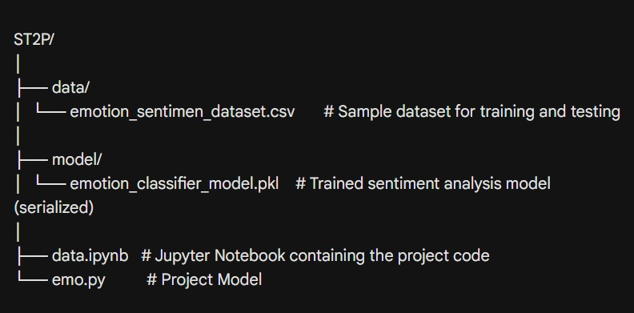

**Algorithms Used**

1. Clean Text & Split Words: Prepare the text data by removing noise and splitting it into usable units.
2. Train Emotion Classifier: Use powerful learning models (Multinomial) to learn patterns that identify emotions in text.
3. Evaluate Model Performance: Measure how well the model works by checking accuracy, precision, and recall for emotion classification.
4. Deploy Model: Save the trained model in a format that allows you to use it for real-world emotion classification tasks.
5. **Results**

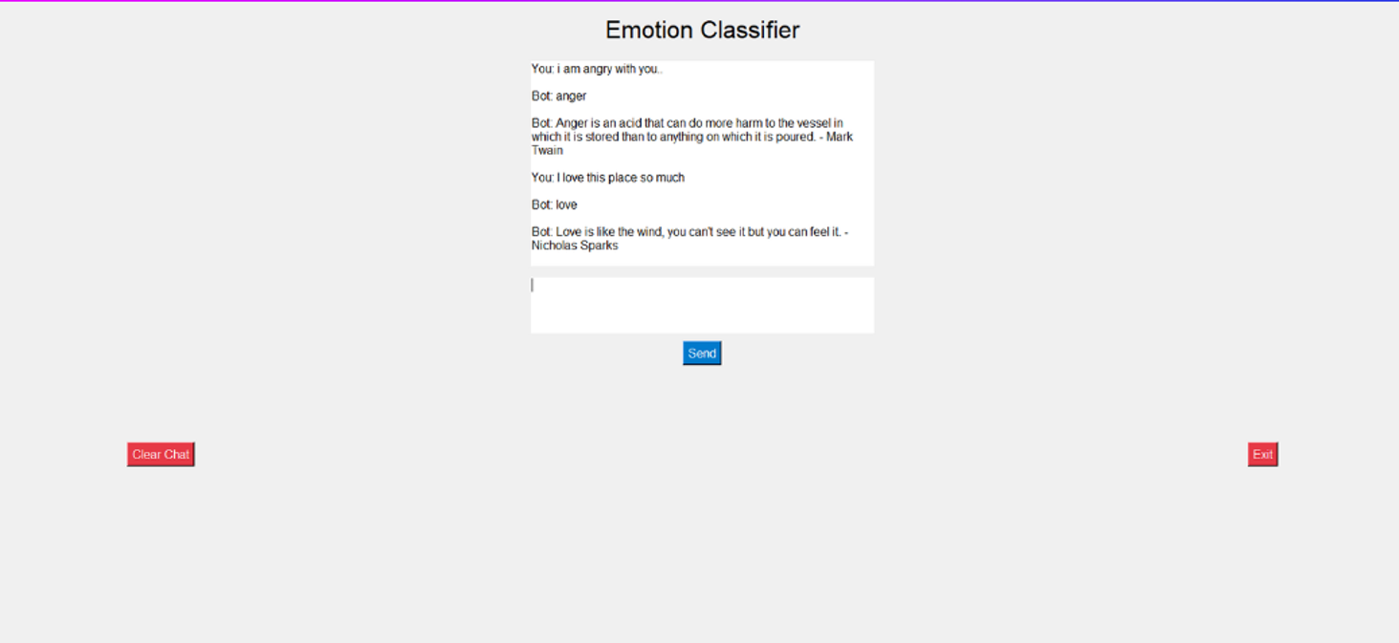

In summary, the **text classification system implemented with Python's supervised learning** automates the categorization of unstructured text data into predefined emotion categories. By utilizing the **Multinomial Naive Bayes** **classifier** and **TF-IDF vectorization**, the model streamlines data management, simplifies information organization, and saves time by eliminating manual categorization efforts. This automated approach holds promise for industries by facilitating improved decision-making, trend analysis, sentiment analysis, and customer feedback analysis.

**5. References:**

|  |  |
| --- | --- |
| 1. PyQt 5 Documentation | https://doc.qt.io/qtforpython-6/ |
| 2. Matplotlib Documentation | https://matplotlib.org/stable/index.html |
| 3. Sklearn Documentation | https://scikit-learn.org/stable/ |
| 4. Data set link | https://www.kaggle.com/datasets/simaanjali/emotion-analysis-based-on-text/data |